D&AI Coding Group – Getting Python Working With Jupyter Notebooks

# Step 0: Setting up Python on your laptop

You can install Python onto your laptop by installing it from the pre-approved software folder on the Deloitte Intranet. To do so:

1. Connect to the Deloitte VPN
2. Navigate to the Analytics and AI pre-approved software folder at the following path:  
    \\AUSYD5704\DeloitteTrustedApplications\Analytics_&_AI  
   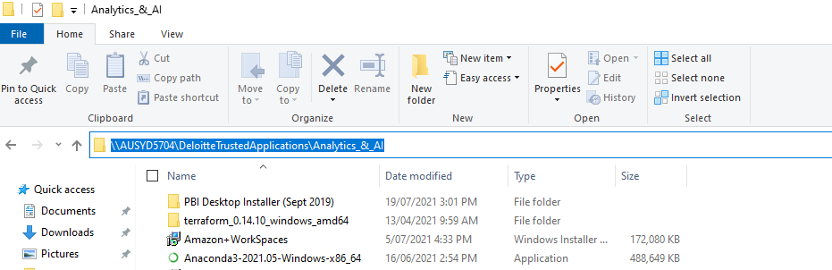
3. Install your desired version of Python (be sure to install it from the network drive, do NOT copy it to your laptop to install)  
   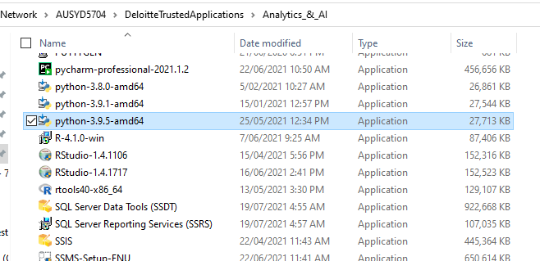
4. Click the ‘Add to PATH’ option on the install splash screen and follow the prompts to Install Now  
   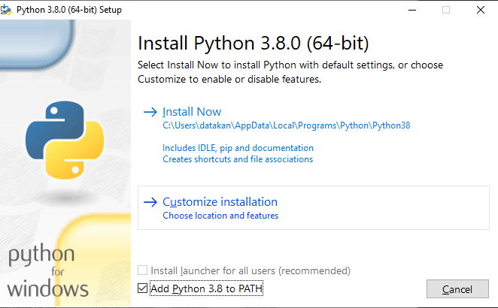
5. Verify your installation by going into Command Prompt and typing in Python. You should then see a screen similar to this, with the version reflecting the version you installed  
   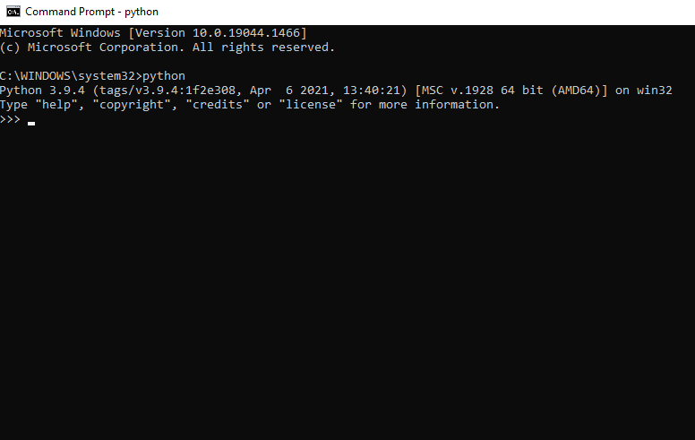

# Step 1: Installing Pandas, Numpy and Jupyter Notebook

To install the relevant libraries for our workshop we need to install them using pip (package installer for Python). To do this, we run the following commands in command prompt:

pip install numpy

pip install pandas

pip install jupyterlab

More generically, you can generally install any python module by using:

pip install <INSERT MODULE NAME HERE>

*if you can’t get the pip install working and keep getting errors, try to do it outside Deloitte network or vpn. Use your own home wifi or the laptop inbuilt-sim

# Step 2: Accessing the Workshop Notebook

Now that we have all our packages installed, we need to access our workshop notebook.

To do this we are going to be using a Jupyter notebook which is an excellent way to have an interacting coding environment where you can do anything from exploratory data analysis, through to developing a full machine learning model.

The way Jupyter notebook works is that it creates a server on which you can run your notebooks.   
To do this:

1. Navigate to the directory where you’ve downloaded your notebook for the workshop and in the address bar, type in ‘cmd’ and click enter  
   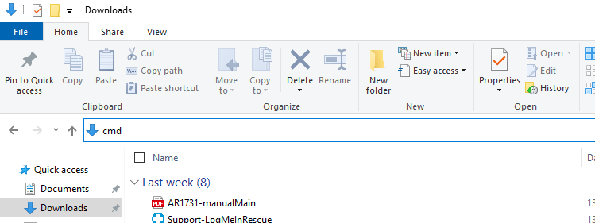
2. In the command prompt window that opens, type in:  
    jupyter notebook  
   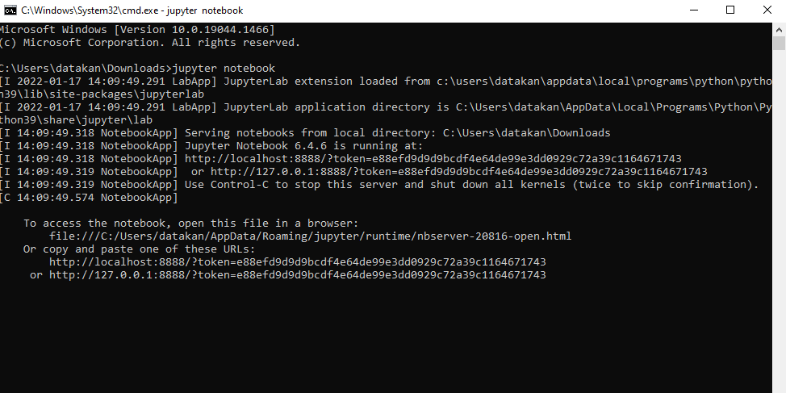
3. Select the notebook that you want to run. This should then open in a new tab  
   